SCHOOL ANTI-BULLYING POLICY

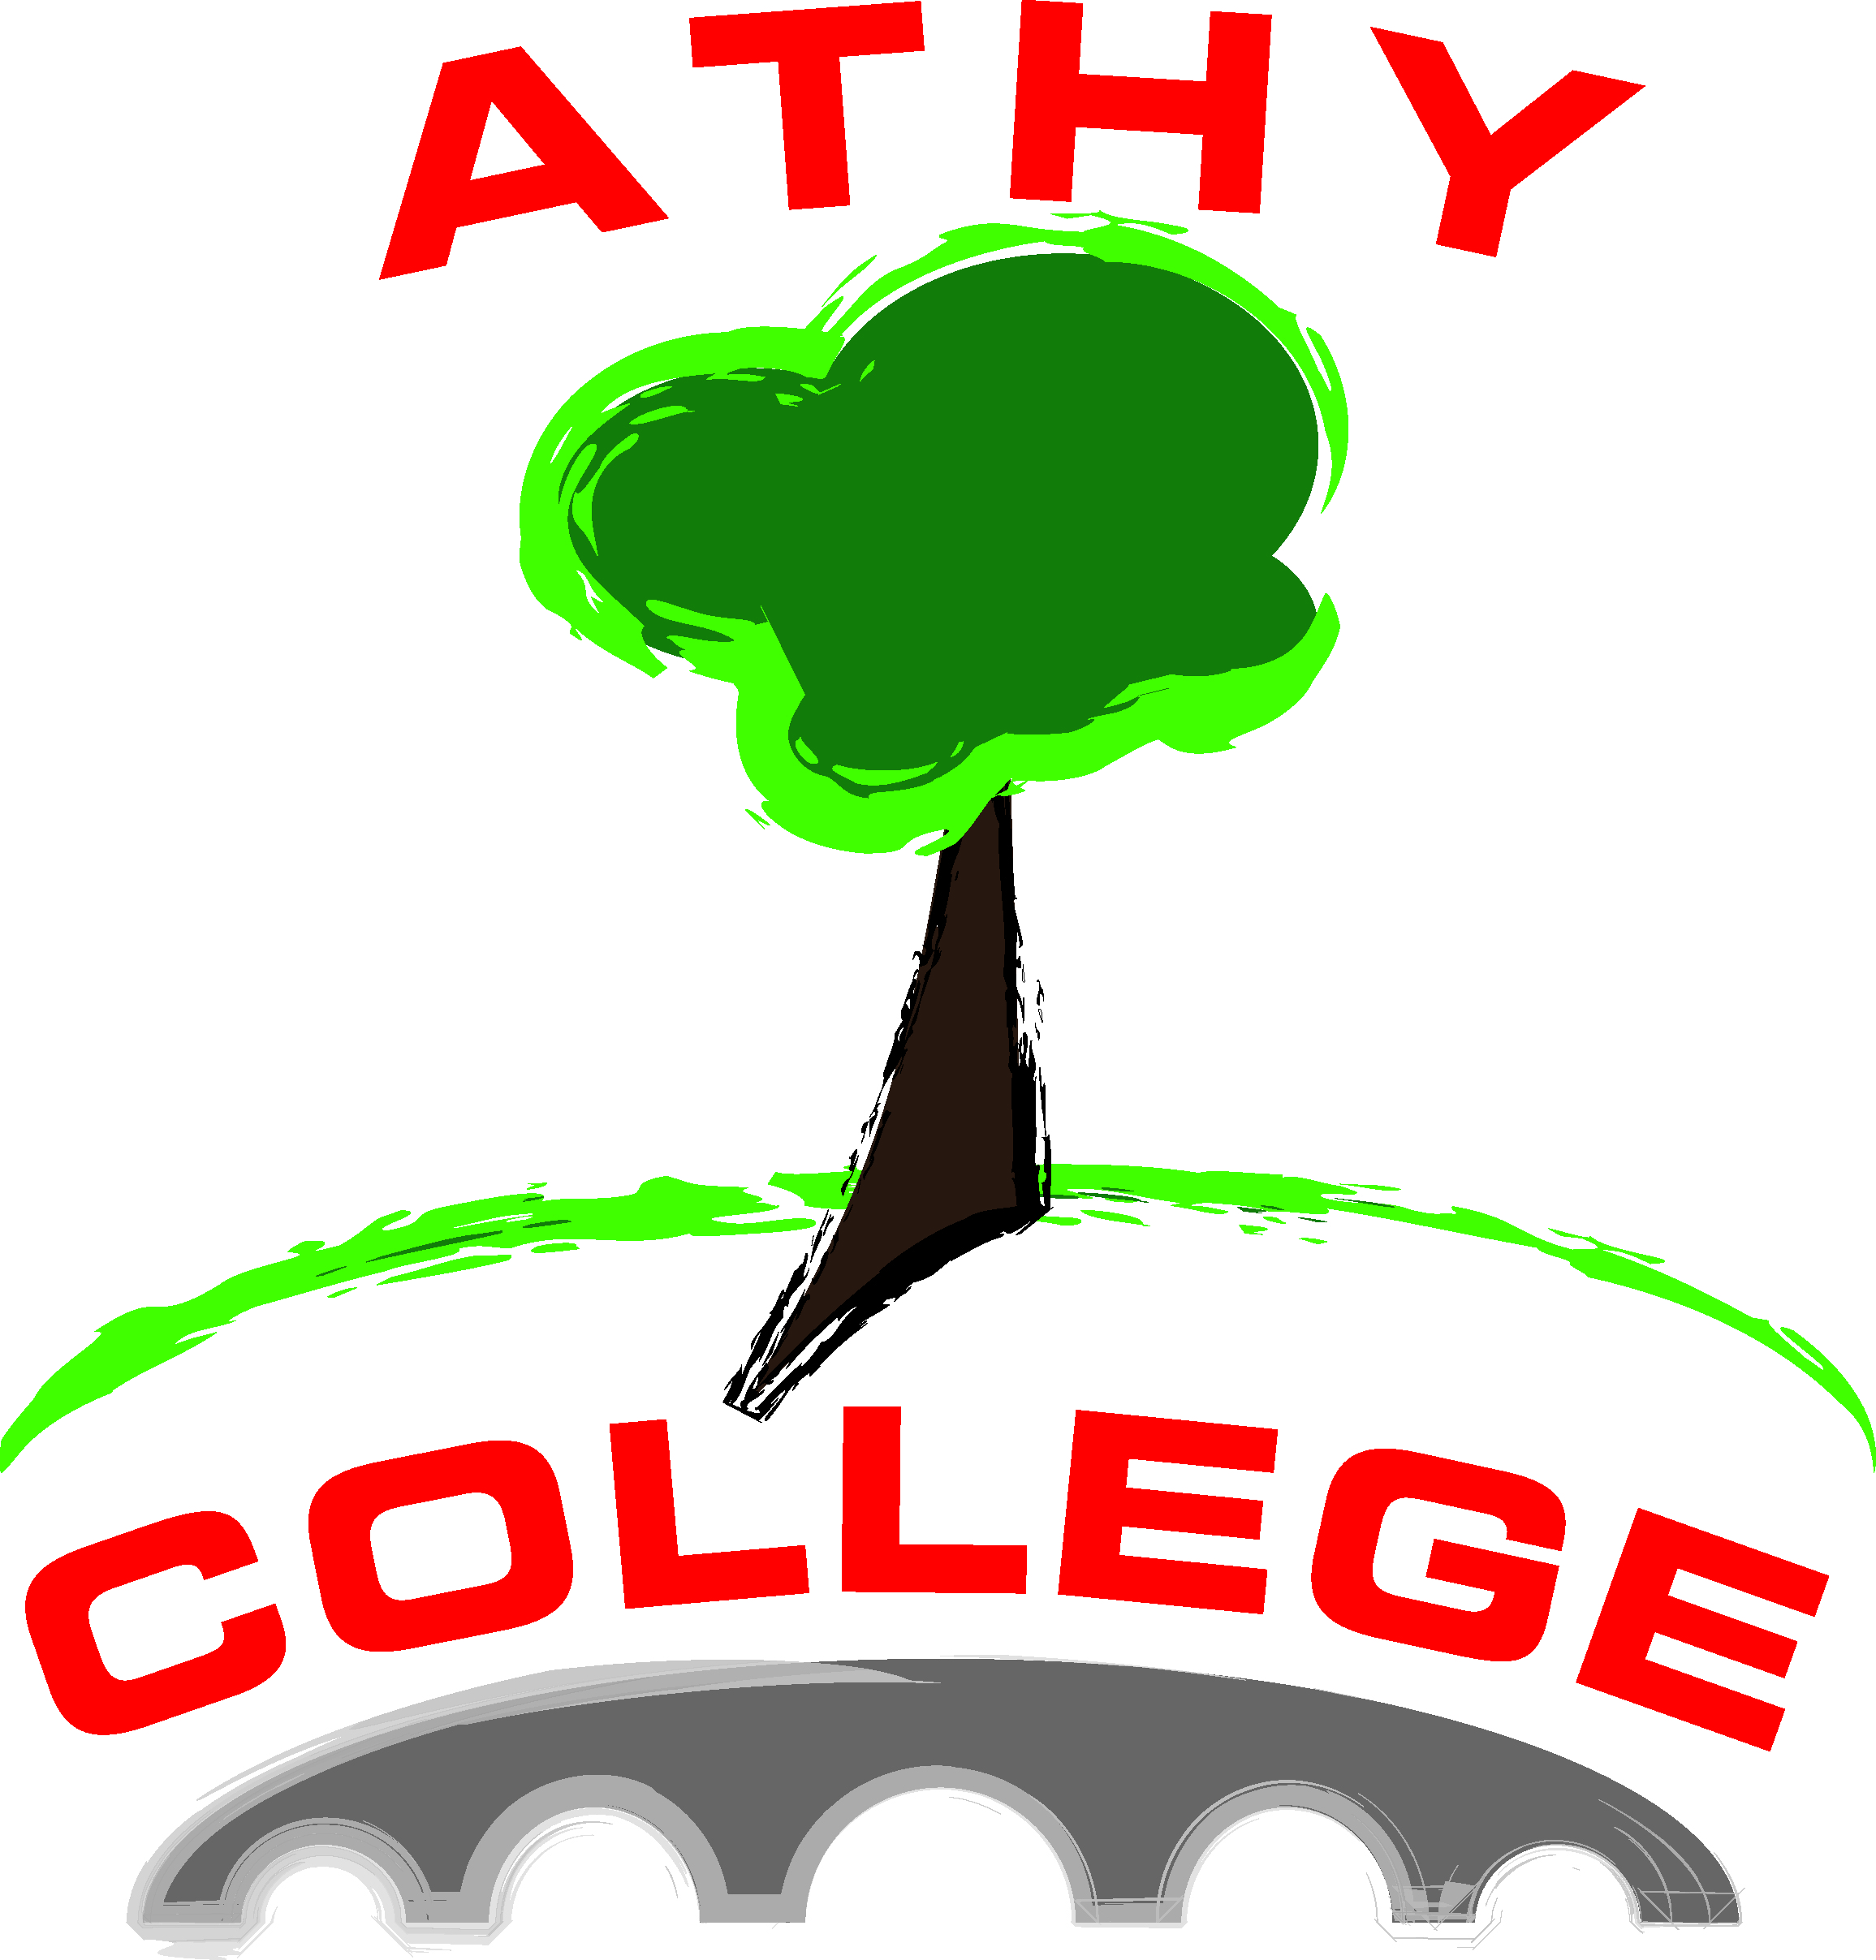

ATHY COLLEGE
Athy
County Kildare

Mission Statement

‘In a caring school we are dedicated to fostering educational excellence empowering all students to reach their full potential – academic and social, physical and spiritual. Through partnership and co-operation we openly respect and nuture the dignity and uniqueness of each individual’.

- In accordance with the requirements of the Education (Welfare) Act 2000 and the code of behaviour guidelines issused by the NEWB, the Board of Management of Athy College has adopted the following anti-bullying policy within the framework of the school’s overall code of behaviour. This policy fully complies with the requirements of the Anti-Bullying Procedures for Primary and Post-Primary Schools which were published in September 2013.
- The Board of Management recognises the very serious nature of bullying and the negative impact that it can have on the lives of pupils and is therefore fully committed to the following key principles of best practice in preventing and tackling bullying behaviour:
- A positive school culture and climate which –
- is welcoming of difference and diversity and is based on inclusivity;
- encourages pupils to disclose and discuss incidents of bullying behaviour in a non-threatening environment;
- promotes respectful relationships across the school community;
- Effective leadership;
- A school-wide approach;
- A shared understanding of what bulying is and its impact;
- Implementation of education and prevention strategies (including awareness raising measures) that –
- Build empathy, respect and resilience in pupils;
- Explicitly addresses the issues of cyber-bullying and identity-based bullying including in particular homophobic and transphobic bullying.
- Effective supervision and management of pupils;
- Support for staff;
- Consistent recording, investigation and follow-up of bullying behaviour (including use of established intervention strategies);
- On-going evaluation of the effectiveness of the anti-bullying policy.

- In accordance with the Anti-Bullying Procedures for Primary and Post-Primary Schools bullying is defined as follows:
Bullying is unwanted negative behaviour, verbal, psychological or physical conducted, by an individual or group against another person (or persons) and which is repeated over time.
The following types of bullying behaviour are included in the definition of bullying:
- Deliberate exclusion, malicious gossip or other forms of relational bullying;
- Cyber-bullying;
- Identity-based bullying such as homophobic bullying, racist bullying, bullying based on a person’s membership of the Traveller Community and bullying of those with disabilities or special educational needs.
Isolated or once-off incidents of intentional negative behaviour, including a once-off offensive or hurtful text message or other private messaging, do not fall within the definition of bullying and should be dealt with, as appropriate, in accordance with the school’s code of behaviour.
However, in the context of this policy, placing a once-off offensive or hurtful public message, image or statement on a social network site or other public forum where that message, image or statement can be viewed and/or repeated by other people will be regarded as bullying behaviour.
Negative behaviour that does not meet this definition of bullying will be dealt with in accordance with the school’s code of behaviour.
Additional information on different types of bullying is set out in Section 2 of the Anti-Bullying Procedures for Primary and Post-Primary Schools.

- The relevant teachers for investigating and dealing with bullying in Athy College are as follows:
- The Class Tutor
- The Year Head
- Serious incidents of bullying referred immediately to Deputy Principal and Principal
Note: Athy College Anti-Bullying Policy, page 7, sets out the procedures for investigating and dealing with bullying behaviour.

- The education and prevention strategies (including strategies specifically aimed at cyber-bullying and identity-based bullying including in particular, homophobic and transphobic bullying) that will be used by the school are as follows:
Education Strategies:
- Social, Personal and Health Education classes
- Relationship and Sexuality Education classes (incorporating education on sexual identity and orientation)
- Leaving Certificate Applied Social Education classes
- School charter in all students’ journals for positive behaviour
Prevention Strategies:
- Referral to Care Team
- Referral to School Completion Programme Anger Management Support
- Referral in consultation with parents to specialist agencies outside school setting:
- Child and Adolescent Mental Health Service
- HALO
- Pieta House
- Kildare Youth Services Adolescent Counselling
- HSE Social Services

- The school’s procedures for investigation, follow-up and recording of bullying behaviour and the established intervention strategies used by the school for dealing with cases of bullying behaviour are as follows:

If bullying occurs, the victim, the bully and any witnesses will be interviewed. A calm, problem-solving approach will be adopted when dealing with incidents of bullying behaviour.

The Victim
- Victim is listened to by tutor/ year head/ HSCL and/or other teacher and allowed tell their story.
- Student is asked to write own account. Teacher reassures victim that nobody deserves to be bullied and works with them to plan for a solution to the problem.
- Teacher assures victim of continued support and continued security - through the limited hours of the Guidance Counsellor, HSCL coordinator, year head and possible outside agency.
- Teacher explains to the victim that the incident will be fully investigated with help from others present at the incident, i.e. witnesses. Other people may have to be informed, i.e. Principal, parents, year heads.
- Victim will be kept informed of how the matter is proceeding.
- If and when ready, the victim may get an apology from the bully.

The Bully
- Bully will be helped to see how their actions are damaging. They will be constantly reminded that bullying behaviour is not acceptable in Athy College.
- Disciplinary sanction will be imposed on the bully.
- Tutor and year head will make an agreement with the Bully on how to stop the bullying behaviour.
- In time, when the victim is ready and when the bully has come to an understanding of their actions, the bully may apologise to the victim.
- Tutor/year head will seek the support of the parents of the bully to reinforce the sanctions imposed.
- Principal/deputy Principal may be involved if the incident is found to be very serious or if the parents of the bully do not offer their support.
- If no agreement is reached, the incident may be referred to the Board of Management.
- Failing agreement again, the incident may be referred further to the V.E.C. committee.

The Witness
- Tutor /year head/ HSCL/ Guidance Counsellor will interview witnesses to help get a full account of an incident.
- Witnesses will be asked to write their account.
- Witnesses will be encouraged to come forward at all times and to stand up for the victims.

Procedures for Noting and Reporting an incident of Bullying Behaviour

- Students are to be supported and encouraged to report all incidents of bullying to their tutor/ year head/ HSCL coordinator/ Guidance Counsellor(or any member of staff), which then must be investigated. In this way students will gain confidence in reporting. A teacher who witnesses bullying will also report the incident to the class tutor.
- All incidents of bullying behaviour are recorded on the template set out in Appendix 3 of the Department of Education and Skills Anti-Bullying Procedures for Primary and Post-Primary Schools
- The teacher who witnesses or to whom the bullying incident is reported, in conjunction with the tutor, will inform the year head in writing.
- The year head will investigate and deal with the incident in accordance with the school’s Code of Discipline.
- A serious bullying incident will be referred to the Principal or Deputy-principal. The expertise of outside agencies may be sought where needed.
- Parents/guardians of victims and bullies will be informed by the year head/ HSCL coordinator at the earliest opportunity to allow for discussion of the matter.
- Non-teaching staff members are encouraged to report any incidents of bullying behaviour witnessed by them.

Procedures for Investigating and Dealing with Bullying Behaviour
(In accordance with Code of Discipline)

- All parties are interviewed separately (victim/bully) by tutor and year head.
- If a group is involved, each person will be interviewed separately and asked for their account of the incident.
- Interview will be conducted in a non-leading and non-confrontational manner.
- The school personnel will keep a written record of the interview. Students involved will be asked to write down their account of the alleged incident.
- After investigation, if behaviour is considered to be a bullying situation, the year head may inform parents/guardians of the individuals involved.
- Students involved in bullying behaviour will be informed that they are in breach of the Code of Discipline.
- Victim will be offered continuing support, as deemed necessary, in consultation with parents. e.g. via the tutor, year head, principal, HSCL Co-ordinator.
- As well as being disciplined, the bully will be supported in developing awareness of the effects of their behaviour on others and of the necessity to stop this behaviour.
  - Support may be sought from:
  - Kildare Youth Services
  - Health Board
  - Child and Adolescent Guidance Service
  - Garda Juvenile Liaison Officer

Disciplinary Measures against the Bully
- The student who has engaged in bullying behaviour will be disciplined with an appropriate sanction, as detailed in the Code of Behaviour
- This student will be asked to look at the situation from the victim’s point of view.
- The parents of a student involved in bullying behaviour may be invited to come to the school to discuss ways in which they can reinforce or support the action being taken by the school.

- The school’s programme of support for working with pupils affected by bullying is as follows:
- Support from Class Tutor and Year Head
- Referral to Care Team
- School Completion Programme Anger Management Supports
- HSCL linking with the parents / guardians of the student
- Referral in consultation with parents to specialist agencies outside school setting:
- Child and Adolescent Mental Health Service
- HALO
- Pieta House
- Kildare Youth Services Adolescent Counselling
- HSE Social Services

- Supervision and Monitoring of Pupils
The Board of Management confirms that appropriate supervision and monitoring policies and practices are in place to both prevent and deal with bullying behaviour and to facilitate early intervention where possible.

- Prevention of Harassment
The Board of Management confirms that the school will, in accordance with its obligations under equality legislation, take all such steps that are reasonably practicable to prevent the sexual harassment of pupils or staff or the harassment of pupils or staff on any of the nine grounds specified i.e. gender including transgender, civil status, family status, sexual orientation, religion, age, disability, race and membership of the Traveller Community.

The policy was adopted by the Board of Management on ________________________ (date).

This policy has been made available to school personnel, published on the school website (or where none exists, is otherwise readily accessible to parents and pupils on request) and provided to the Parents’ Association (where one exists). A record of the review and its outcome will be made available, if requested, to the patron and the Department.

Signed: __________________________ Signed: ____________________________
Chairperson of Board of Management Principal

Date:____________________________ Date:_______________________________

Date of next review: ____________________________

